What are chlorhexidine-containing dressings?1

Chlorhexidine-containing dressings include the antiseptic chlorhexidine as a part of the dressing. These have been associated with decreased CLABSI rates in acute care hospitals.1 The chlorhexidine can come in the form of a chlorhexidine-containing sponge dressing that can be applied directly to the catheter insertion site. The chlorhexidine can also come in the form of a transparent dressing infused with chlorhexidine. Chlorhexidine-containing dressings should not replace chlorhexidine scrubbing of the skin with dressing changes.

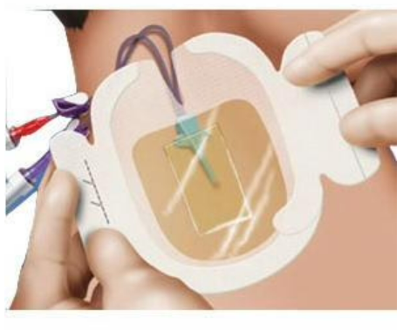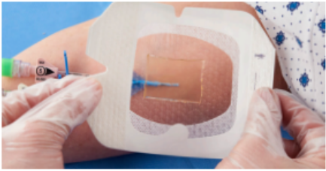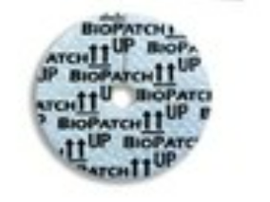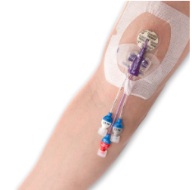

Who should use chlorhexidine-containing dressings?

Chlorhexidine-containing dressings are considered an essential practice in reducing CLABSIs.1 Any patient who does not have an intolerance to chlorhexidine should use chlorhexidine-containing dressings.

How do you use chlorhexidine-containing dressings?

Use the chlorhexidine-containing dressings during each scheduled and unscheduled dressing change.

*If you are using a chlorhexidine-containing dressing:*

1. Clean and prepare the skin using a chlorhexidine skin scrub.
2. Allow the chlorhexidine skin scrub to dry.
3. Peel the liner from the dressing.
4. Turn the dressing over so that the adhesive faces the skin. If there is a gel pad on the transparent dressing, make sure the gel pad covers the catheter insertion site and any sutures. Do not stretch the dressing.
5. Push first on the gel pad, then firmly to the entire dressing to ensure adherence.
6. Apply pressure to any border with one hand while removing the paper frame with the other hand.
7. Remove the tape strip.
8. Document the dressing change information on the label strip.

*If you are using a chlorhexidine-containing sponge dressing:*

1. Clean and prepare the skin using a chlorhexidine skin scrub.
2. Allow the chlorhexidine skin scrub to dry.
3. Use sterile technique to place the sponge dressing at the catheter insertion site, using the slit in the sponge dressing to allow the sponge to completely surround the insertion site including under the catheter. Make sure the print side is up and the slit faces away from the catheter.
4. Peel the lining from the dressing.
5. Turn the dressing over so that the adhesive faces the skin. Be careful to not dislodge the sponge dressing. Do not stretch the dressing over the catheter.
6. Push first on the sponge dressing, then firmly to the entire dressing to ensure adherence. Apply pressure to any border with one hand while removing the paper frame with the other hand.
7. Remove the tape strip.
8. Document the dressing change information on the label strip.

Consider adding the chlorhexidine-containing sponge dressings or chlorhexidine dressings to dressing kits or supply packages. Train staff in how to use these dressings. Review use of these dressings in competency assessments.

Reference

Buetti N, Marschall J, Drees M, et al. Strategies to prevent central line-associated bloodstream infections in acute-care hospitals: 2022 Update. Infect Control Hosp Epidemiol. 2022;43(5):553-569. doi:10.1017/ice.2022.87